Activities to Keep Your Kids Busy

By Maria Concepcion, Global Family & Home Care, President

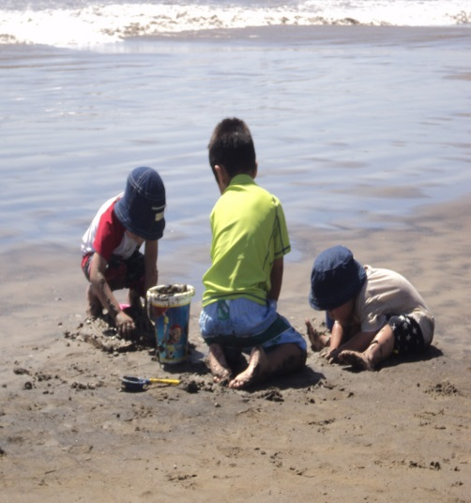

Summer is fast approaching. Instead of letting kids become couch potatoes playing video games, plan some fun activities to show them how much there is to do in their surroundings. Encourage them to explore the outside world. Find out what your kids like and encourage them accordingly.

Ms. Concepcion, from Global Family & Home Care, stresses the importance of making kids’ summer vacation interesting while also reinforcing important educational skills and nurturing valuable family time.

Here are many ideas for you to explore. Try some and enjoy your summer.
Reading is a must: Make sure that you supply them with suitable literature for their age. Reading from an early age improves their language, imagination and moreover knowledge. A piece of advice: explore your children reading interests so they can be truly engaged with their readings, and allow them to read graphic novels (previously called cartoons). Many children who are intimidated by long chapter books, or just don’t have interest in reading, can usually be persuaded to read graphic novels as a way to spark their interest in reading.

Writing is fun: Kids generally want to share their imaginations, and writing is a great vehicle for kids who might be shy to express themselves freely. Ask your kids to write an essay about something that they like. Encourage journaling because it will become handy at the beginning of the academic year when teachers ask for essays about their summer experiences.
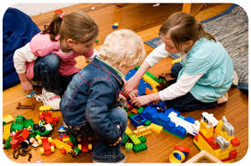
Indoor games: Although some people think that indoor board games are a thing of the past, it’s not true. Some research studies suggest that kids who play more action packed video games can make kids, and teenagers, more violent and aggressive than kids playing less video games. In comparison, with board games, kids tend to develop strategy.
Block Creations: Lego blocks and toys have been entertaining kids for some decades now. Blocks are good for fine motor skills and creativity, among other things.
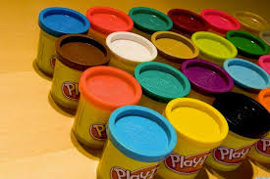
Playing dough or Silly Putty: Kids usually get very involved with these materials without getting bored. You can encourage kids to build simple sculptures and graduate into building complicated building structures as they get older and much more mature with their fine motor skills.
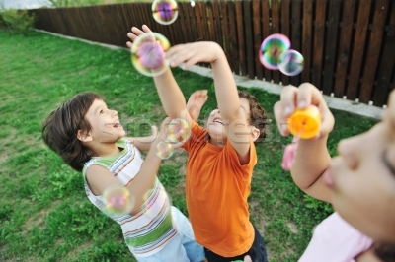
Bubble Fun: Bubble making is a great inexpensive pass time. Kids can compete about the size, quantity or longer lasting bubbles.
Music & Dancing: Music and Dancing encourages movement, rhythm, memorization, pronunciation, and motor skills, among others.
Karaoke for the teens: This is a great way to keep them entertained for a long period of time, improve their reading, presentation demeanor and self-esteem, among others.
Movement Games: Musical chairs can be fun to encourage physical activity and this game can be shared by little ones and older kids alike. Let them chose the music for the game so they can have ownership of their game.
Handmade toys: Handmade or homemade toys are a great learning experience, while also reinforcing fine motor skills, eye-hand coordination and many other educational skills. You could make cars to do a car race; train wagons to build an entire train track with bridges; build skateboards to play outside. They can also make dolls or simple puppets. If you think your kid is interested and has talent for acting, expose him/her to the art of puppetry.
Crafts: Handmade crafts are a very good idea for kids to have fun. You could try making decorative pillows, placemats, miniaturizing things, making pendants, paper flowers, necklaces, ceramic items, indoor garden, conch sculptures, paper windmill and many more.
Painting and Drawing: Drawing and painting are great ways to keep the kids busy. There are a variety of techniques and textures they can explore while also improving their regular practice. When they are smaller, let them draw whatever they like or ask them to draw anything that attract them from their surroundings. As they get a bit older, you can visit the Art Institute to encourage and inspire their drawing.
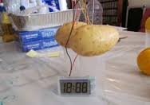
Science projects: If your kids are enthusiastic about science, then perhaps think of simple science projects that your kids can do at home. Google search for some quick and simple experiments, and visit the Science Museum for additional science exploration and fun.

Bike wash: Most of the kids have their own bikes. Why not tell them to wash it once a week during summer vacation. Washing bikes can be fun as kids love playing with water. They can organize a bike wash drive for a good cause in the neighborhood. This experience can serve as service-learning hours for high school students.
They will also learn about business and will practice their math skills.
Volunteering and getting involved in social causes: You not only keep your kids busy, but nurture a sense of social responsibility and good values. Ask your kids to prepare greetings for soldiers and ill people at a hospital. A greeting from kids can be very much refreshing for both sick people and soldiers.

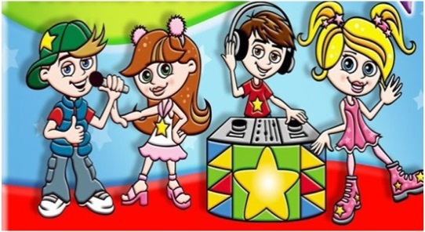
Neighborhood Talent Show: An article I read from Care.com provided this cool idea. Make an announcement in your neighborhood about a talent show for kids. This would be a wonderful time for kids not only to hang out with their buddies, but also to discover their hidden talents.
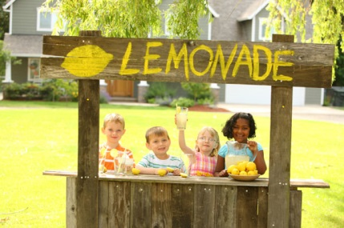
Lemonade Sale: Ask your kids to identify a good cause to raise funds for in their neighborhood and do a lemonade fundraiser. By selling lemonade, your kids will practice math skills, learn about money profits, money management. Further, this type of project will teach them the basics of running a business and entrepreneurship.

Mowing the lawn: If your kids are in their early teens, you can encourage them to clean your lawn. Advise them to offer their services to your neighbors. This type of activity teach them to earn their own pocket money.
Jewelry and accessories: Making homemade jewelry and accessories can also be another great idea for keeping your kids busy. They can learn about gems, a variety of materials, and simple tools.
Live Angry Birds: We all know how much kids love Angry Birds. Encourage your kids to make real Angry Birds game by using a simple catapult, paper balls as Birds and Piggies and Cardboard boxes as Piggy Castles. The game itself can be so much fun for kids. For additional fun, video shoot and upload on YouTube your own game and check the responses you get.
Low-Cal Ice cream or Yogurt making: This is another great way to keep your kids busy. Show them the basics of ice cream making and ask them to prepare ice creams with their favorite flavors. This is a great opportunity to review some science concepts and other sweet nutritional recipes.
Photography: Taking pictures can be so much fun. Give your kids a camera that doesn’t cost much and let them take pictures of themselves, things around your home, and all their activities during the summer. After they’ve taken about a dozen or two, check whether they’re good enough to be printed. Print them and start a scrapbook. At the end of the summer, some of them can be blown up as posters for their rooms. Note: this can be a good start for a Young Authors book when the teacher ask them to write their stories the following school year.
Treasure hunt: We’re not talking about the classic treasure hunting. Hide few souvenirs in your house at different places. Of course, make sure your kids don’t know a thing about it. Ask them to search at different places in your home and find those pieces of treasure. If you’re worried about home being ransacked by your kids, plant these souvenirs outside of your home, in the garden. Ask your kids to be careful with plantation pots in the garden.
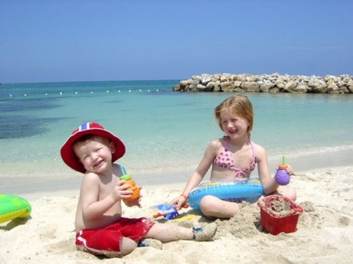
Pools and beaches: If possible, take your kids to a vacation to the nearest, clean and safe beach. Playing on the beach sand, your kids will have so much fun and they’ll be occupied for hours together. Even parents can have fun times of their own. A neat idea is to plan this vacation with one of your close friends, colleagues or a very close neighbor. If two families with kids can come together, the fun can be doubled.
Fishing trip: For a change, take your kids to a fishing trip. For first timers and kids, simple fishing rod with no complications would be enough. While fishing, do tell them stories or encourage them to sing as kids easily get bored waiting for a fish to catch the bait.
Soccer or baseball practice: If your kids are interested in sports, you could take your kids to nearby soccer practice or baseball practice, if possible. Playing for few hours a day can be fun and they would be easily exhausted and can go to bed at the right time.
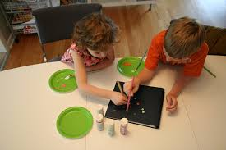
Watch a movie with kids: Watch an afternoon movie with your kids, at least once in a while. You could watch the movie, if you can or let the kids watch the movie and the parents can spend some quality time together.
Videography: They can take cell phone pictures and by using a simple Windows or Apple software program, your kids can create movies to burn on DVD or upload to YouTube.
Visit a library or a museum: It’s doesn’t sound like much of a fun, but you can also try museum or a library. Kids would also like to know more about history. Your kids can be eager to listen to legendary tales about some of the greatest people in the past. They’ll be eager to know about how people lived hundreds or even thousands of years ago. When you take to a library, teach them to maintain silence before hand and straightaway take them to the kids section. Thus, you can avoid any embarrassments. If possible, check whether there are special libraries for kids.
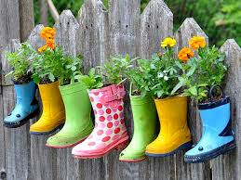
Gardening: Gardening can be another way of having fun with your kids. You can teach your kids about the importance of gardening and how it helps, how plants are good for the environment, how to plant them and how to take care of them, etc. Kids tend to remember all the good things that have been told to them from a very young age. And as they grow older, they develop a deep respect for the environment around them. And gardening can be starting point for that. Apart from gardening, you can take your kids out to a nearby farm and show them how farming is done and where do we get our food.
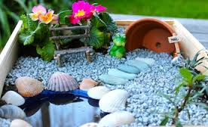
Miniature garden: Mini garden is a cute idea. All it requires is a large empty cool drink bottle, soil and few seeds of herbs. Make a small hole directly above the soil for watering and keep it at the window where there is sunlight. Within in few days, the seeds will germinate and small plants start growing.

Bonsai plants: Another tip for gardening enthusiasts out there. Have your kids grow bonsai or miniature trees. Another great way to teach basic gardening skills to your kids. Kids would love to see a bonsai tree because they’ll love the idea of miniature tree.
Making and flying kites: If you happen to live open spaces, then flying kites can be a very good pastime. You can make kites of your own with little effort and fly them for your kids. If your kids are old enough, show them how to make kites and they’ll make them on their own.

Origami: Origami is a traditional form of paper craft from Japan. Origami is famous for making faces, animal shapes, flowers and other structures from paper. A great form of artwork that your kids can learn. There are books available on Origami for kids and advanced Origami.
Pet care: If you have pets at home, ask your kids to take the pet out for a walk, feed it from time to time and the most important thing, washing your pet is more important. Show them your kids, how to wash your pet, if it is washable at all and encourage them to wash it at least once a week and groom it. This can be very exciting for kids as they’ll be as creative as possible in decorating their favorite pet after the wash.
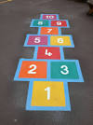
Exercise: Yes, you’ve heard it right. Summer is not just a time for having fun and being lazy sitting at home. It’s also important to be fit. Encourage your kids to get up early in the morning and exercise. Exercise is also important for parents as well. Exercise along with your kids.
Hopscotch: Hopscotch is a simple outdoor game for kids. It’s an easy to play game that can be played almost anywhere, alone or in a group. Girls, especially love this game for its simplicity.
Learning a foreign language: If you’re kids are enthusiastic and fascinated towards any foreign language, this is the best time to begin. Foreign languages like French, Spanish, German, Japanese, Korean or any other language can be an option. Learning a foreign language can be very beneficial as it would save the burden of learning a new language in the future, if the need be. Today, we are global citizens and knowledge of a foreign language opens new avenues in career.
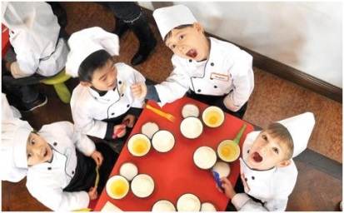
Table Football: A simple Table Football can be a great option if you have boys at home. The dad can show some tricks of the business and we’re sure, your kids would be addicted to table football all through the summer and will spend many hours trying to beat each other out.
Cooking with kids: If you think that your kids are old enough to know that fire and kitchen knives should be handled with respect and care, you can introduce them to cooking. Cooking is a great way to pass time and be very satisfied at the end of the day. Also by introducing cooking to kids, you can make sure that your kids can have healthy homemade food rather than unhealthy fast foods.
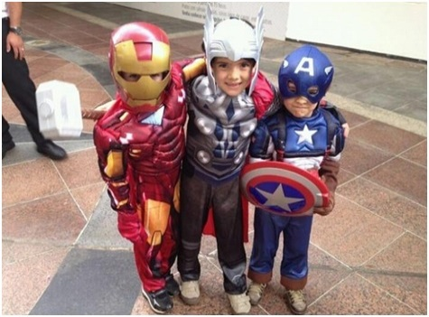
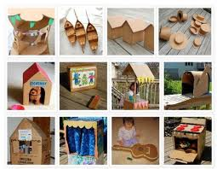
Hero or Character Play : Your kids can dress up like their favorite characters from one cartoon show or movie or novel. Invite your child’s neighbor friends, or friends from school to a Hero Play Day. If you are brave enough, you can make it an overnight stay. Harry potter, DC characters and Marvel characters can be some of the options. Cartoon costumes can cost you dearly, so go with cheaper options, or do the costumes yourself. Thrift stores can be an inexpensive option to find some of the accessories needed for the costume
Cardboard Projects: Cardboard projects make summer vacation much more fun, both for kids and parents alike. Kids love to make castles, and many other structures, with them. Parents, other family member, or neighbors, can become involved with the cardboard project. Aside from all the fun, there are many math, science, reading and physical skills involved in building a cardboard structure.
Dressing up: Let your kids dress up in their favorite clothes more often during summer vacation. This is a great time to teach color coordination and proper clothing for different occasions. Take advantage of this nice dress up time to do some musical or theatrical activity.
Ms. Concepcion, from Global Family & Home Care, indicates that, “as parents with plenty of previous experiences, we can come up with many more ideas”. There are also many internet resources to point us to many places where we can spend fun and educational time with our kids. Just be open to all possibilities and don’t hesitate to try new things this summer. For additional helpful Family and Home Care information visit www.globalintervisions.com

